1. 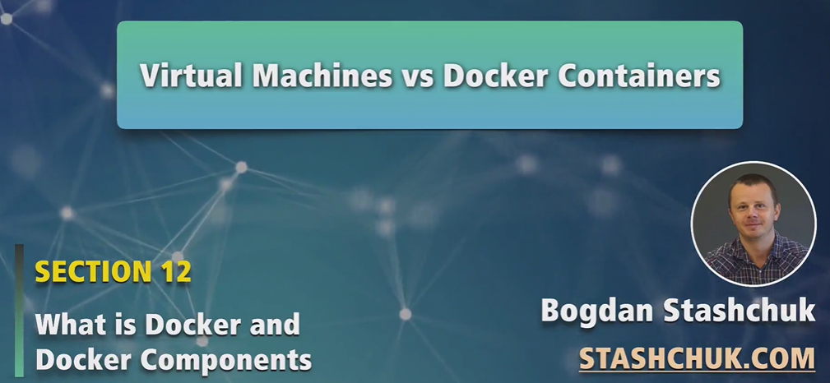
2. 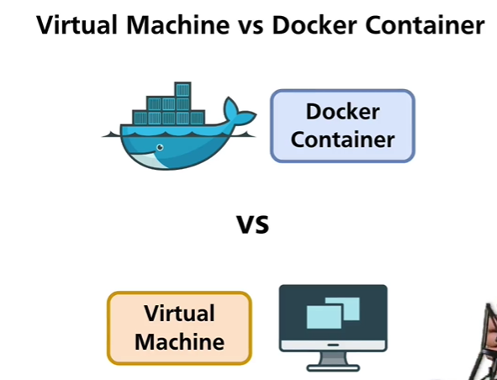
3. There are advantages and disadvantages of virtual machine and Docker container. Based on our requirement, we choose one of them.
4. We can create MAC virtual machine on windows computer and vice versa. (MAC: Operating System)
5. Virtual machines are even created in cloud hosting service and you’re able to run virtual machine just for some dollars per month and you get access to Linux-like System and then you’re able to host you web site or something like there.
6. Let’s dive deep in virtual machine architecture in next section.